IELTS Writing Evaluation Platform
Free Version: GPT mini
Paid Version: GPT Full

FREE Version
Homepage – mock test (free option) – general/academic – test 1 (listening, writing, reading) – php
When they click on writing test, It opens up: writingtest.ieltsprepandpractice.com
This page has
Writing Test instructions, and sign up and login option.
- On clicking sign up button: sign-up form (name, email (email verification is must), contact, country, test type (academic or general training), password) opens up as a pop up.
- When they fill all these details, on clicking submit button, the writing test 1 starts.
- These details should be saved, so next time when student click on Test 2, they will simple use email, password and click on login in to start test.
- Login option should have forgot password option as well. When they click on that, our system should generate random password and send it to them on email.
From where they can buy paid tests:
- On homepage, right next to Free option in mock test, we have purchase now option as well. Students will click on it and it opens the page: (buy.ieltsprepandpractice/mock-tests.com)
- This page requires a name, email (email verification is must), contact, country, test type (academic or general training). Then paying details of credit card or paypal etc.
- When they have paid, the information should come in to admin panel in Registrations section.
Test Environment
Once the students have entered in any test this is how the test platform will be like:
- Header:
  - Timer in the center of the screen (1 hour, auto-submit/save after 1 hour, flashes or changes color when 5 minutes are left).
  - Student name is shown on the top left corner. Along with this a button which says: Go to Dashboard. On the right side of “Go to Dashboard button” we will show the remaining tests a student has in this free or paid option.
  - Settings menu on right: Font size adjustment (it will increase or decrease the font size of the text in question and answer box, Dark/Light mode.
  - On right corner along with settings button, we have logout option.
- Task 1:
  - Task 1 comes first.
  - Question on left – added by admin
  - Answer Text box on right where will student will write with word count on bottom of this text box.
  - Word counter should turn red when the words are more than 180, and don’t let them write more.
  - Support to add images on the left side with question – added by admin
- Task 2:
  - Question on left, answer box on right with word counter at bottom.
  - Word counter should turn red when the words are more than 320 words, and don’t let them write more.
Footer
  - It is on the user which task he/she wants to do first. We will add arrows button on bottom center of the screen, through which the user can move from task 1 to task 2 and vice versa.
  - Submission button on the right bottom corner.

Result Display Page (results.ieltswriting.ieltsprepandpractice/test1/user1.com)
First Average Overall Band Score (of both tasks) is shown
If the student has attempted task 1 and task 2 both then score is calculated according to this formula:
Average band Score = (Task 1 bands) + (2*Task 2 bands) / 3
Example: (6.5) + (2*6.5) / 3 = 6.5 Bands
Rounding off/down rules:
If the average of two is 6.1 – it stays 6 bands overall
- If the average of two is 6.25 or above – it will be 6.5 bands overall
- If the average of two is 6.75 or above – it will be 7 bands overall
- If the average of two is below 6.25 and not 6.25, lets say 6.20 – it stays 6 bands overall
- If the average of two is below 6.75 and not 6.75, lets say 6.65 – it stays 6.5 bands overall

Then we have
- Section 1 (AI Evaluation):
Task 1 Evaluation Report: Shown as a bar, student clicks on it, it drops down and opens the whole report. On the bar, the total score in task 1 is shown.
  - Students response box on left
  - On the right: AI total score in task 1 first, now they clicked on the task 1 bar, the score shown in the task 1 bar before clicking on it should disappear.
  - Then score according to Criteria breakdown underneath it: Task Response, Grammar, Lexical Resource, Cohesion & Coherence. AI should mention the issues/mistakes that student had in their response in each of these criteria along with score in each criteria. They are shown as drop down bars.
  - Then suggestions for improvement, along with button to read a sample answer. Also on the right side

Task 2 Evaluation Report: Shown as a bar, student clicks on it, it drops down and opens the whole report. On the bar, the total score in task 2 is shown.
  - Students response box on left
  - On the right: AI total score in task 2 first, now they clicked on the task 2 bar, the score shown in the task 2 bar before clicking on it should disappear.
  - Then score according to Criteria breakdown underneath it: Task Response, Grammar, Lexical Resource, Cohesion & Coherence. AI should mention the issues/mistakes that student had in their response in each of these criteria along with score in each criteria. They are shown as drop down bars.
  - Then suggestions for improvement, along with button to read a sample answer. Also on the right side
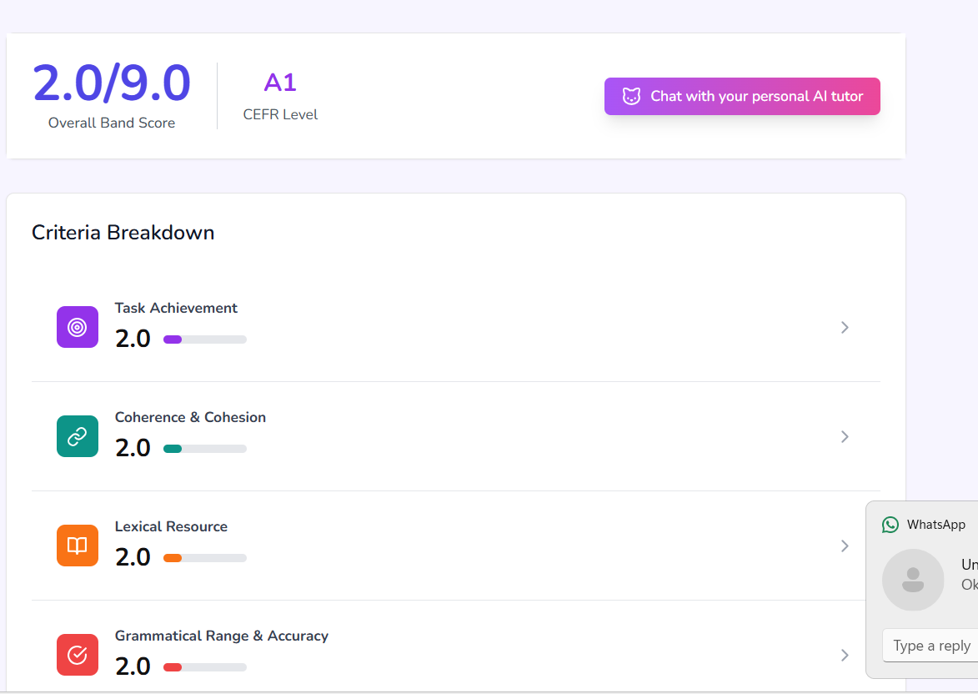
- Section 2: Expert Feedback Section
  - Expert’s Score and Feedback Box (In the box, I (admin) as an expert write students score with some feedback, it will be available after 24 hours, till then we will show the message: Expert’s score will be sent via email after 24 hours and shown here as well).
  - This is added by me from the admin panel.

NOTE: In case a student attempts task 1 only, then the task 2 evaluation report bar is not shown there, and the formula mention above should not work, Simply show the task 1 score on top as well. Similarly if students attempt task 2 only, task 1 evaluation is report bar is not shown there and formula does not work and we show task 2 on top as well in average total band score.

This whole report is saved and sent to Admin panel in Give Feedback Section.

User Dashboard (Free or Paid)
- On top left corner, we show students name.
- On top right corner, we have log out option.
- In the center we show how many tests student has left in free option. When the student has done all free tests, if he clicks on any test again, it will open a pop-up asking them to buy premium version. Purchase now button is available there which will open the payment gateway page (buy.ieltsprepandpractice/mock-tests.com)
- Then on left side, we show a task bar. Where the students can see academic and general training test options. If student selected Academic test while singing up, don’t show general training option here and vice versa.
- On clicking on lets say academic, we will show 8 available tests (depends on how many admin as added). Similarly for general training.

FREE
It has limited number of tests, as many as admin has added.
PAID
It just has more tests than free option, as many as admin has added.

NOTE for FREE and PAID both
When student (free/paid user) has attempted Test 1, and he has done the task 1 and task 2 both, it opens his evaluation report of both tasks as a popup. if he click on this test again, it should not let them retake the same test, simply show him the report with a button to do the test 2.
If done only task 1, option to attempt task 2 along with evaluation report of task 1 should be shown and vice versa.

ADMIN DASHBOARD
In the left task bar:

Option 1: Tests
- Add new test
- Test Name: editable text
- Test Type: Two options: Free or Paid
- Test Category: Two options: Academic or General Training Program
- Goes into separate categories on the website from where users access these tests.
- Test Status: Two options: Active or Inactive, Inactive means it is saved as draft.
Once a test is added, it goes into All tests section.

- All Tests: shows a list of all the tests we have added so far.
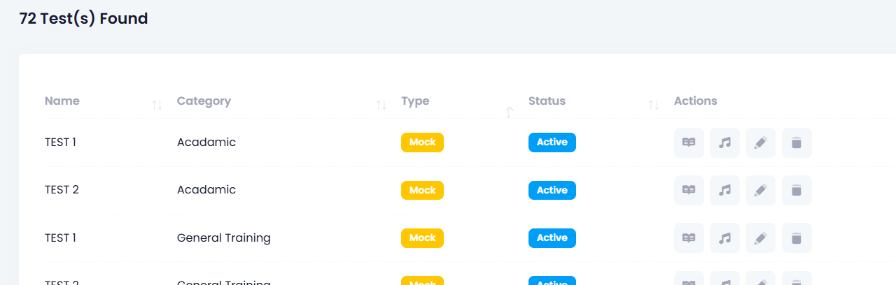

- Now this is the place from where will add/edit/remove the tests, currently we have the option to Edit/reading test (book icon), Edit/add listening test (music icon), change test detail, for example we can change its name, type etc (pen icon), and delete option.
- Here you will add the option to Add/Edit Writing Test.
- Once we click on the writing test icon, it opens a page where we have two options; Add Task 1 and Add Task 2. Simple text boxes, where we add question of task 1 (add picture option in task 1, it should be shown below the question statement in test environment) and task 2. Then save button. These questions are then shown in respective category, also in respective test in cbt.ieltsprepandpractice.com, and test type in Test environment.

Option 2: Users:
- Add user: Give access to students for PAID option.
User details that are added here:
Name, Email, Country, Contact, Password.
This generated email and password is then used at the User dashboard from they can access the paid tests.
- All users: all the users we have added are shown here.

Option 3: Registrations:
It shows registrations made at these links:
- IELTS Mock Test section (buy.ieltsprepandpractice/mock-tests.com)
- IELTS Full Preparation Course (buy.ieltsprepandpractice/full-ielts-course.com)
- IELTS Writing Course (buy.ieltsprepandpractice/ielts-writing-course.com)
- IELTS Speaking Course (buy.ieltsprepandpractice/ielts-speaking-course.com)

Option 4: Give Feedback
Free Access: Responses of all users who are doing the free tests.
Paid Access: Responses of all users who are doing the paid tests.

- Each of these two options when clicked, shows a list of users who attempted the test. For example when I click on User 1 (could be name that’s’ provided when signing up), it opens up his test report generated by AI. This report is taken from the Results page of a user (results.ieltswriting.ieltsprepandpractice/test1/user1.com)
- At the end of this report, there’s an editable text box, where I can write the feedback and score. Then Send button. On clicking the send button, the expert feedback is sent to student via email and shown on the results page of respective user as well.
- Once I have sent the feedback, it should be marked as sent through an icon or any other way.

Payment Gateway Integration
- One payment page is added in IELTS Mock Test section (buy.ieltsprepandpractice/mock-tests.com) in Paid Access option.
- Three payment pages should be added with IELTS Preparation Courses Section with respective courses:
- IELTS Full Preparation Course (buy.ieltsprepandpractice/full-ielts-course.com)
- IELTS Writing Course (buy.ieltsprepandpractice/ielts-writing-course.com)
- IELTS Speaking Course (buy.ieltsprepandpractice/ielts-speaking-course.com)

- The details taken on these pages such as email, name, country, contact is sent to Registrations section in Admin panel.

Command Sent to API

Free Version
- Evaluate this task 1 and/or task 2 according to IELTS Writing Band Score Descriptors.
- Mention the score in each criteria: Task response, Grammar, Lexical Resource, Cohesion & Coherence.
- Mention the mistakes student has made in each criteria.
- Also mention some improvement methods for each criteria.

Paid Version
- Evaluate this task 1 and/or task 2 according to IELTS Writing Band Score Descriptors.
- Mention the score in each criteria: Task response, Grammar, Lexical Resource, Cohesion & Coherence.
- Evaluate the response according to the questions in each criteria:
Task response (Task 2)
- Are the ideas discussed relevant to the question prompt or not
- If the ideas are fully developed with proper reasons and examples or not
- If the student has maintained a clear position throughout the response or not
- Are there any lapses in the content or not.

Task response (Task 1)
- Are the the key features skillfully selected and illustrated or not (academic)
- Are all the bullet points properly addressed with relevant ideas and extended or not (general training)
- Are there any lapses in the content or not.
- If the content given is relevant to the question or not (general training)

Grammar
- Check the grammatical errors (subject verb agreement, use or articles, prepositions, commas)
- Check if the student has used complex sentence structures or not (specifically compound, conditional, compound complex, and relative clauses)
- If the punctuation is used appropriately.

Lexical Resource
- If the vocabulary used is within the scope of the task.
- If the collocations used are error free
- Are there any spelling issues
- If the student has used idiomatic items when appropriate (general training)
- If the word choice appropriate
- Are there any uncommon or advanced words

Cohesion and Coherence
- Paragraphing is used effectively or not (one idea per paragraph)
- If the ideas are logically organized or not, is there a progression in ideas
- Any lapses in cohesion or coherence
- If the student has used substitution and referencing or not.
- If the linking words are used or not, and if they are used naturally and accurately.

- Mention the mistakes students has made according to the question above in each criteria, and give suggestions for improvement as well.

Text Background color changing option in the test environment.
In both current listening/reading test environment and writing platform, we should add background color changing option.
On click the button, students will have three color options: #FFFDD0, #E3F9E5, #FFEFD5.
Default color should be white as of now
When students click on background color changing option, first a pop up opens, a warning with text “this option is only for people with disabilities, don’t use it if you don’t have any kind of disability”

Changes on CBT.IELTSPREPANDPRACTICE.COM
- Make changes in the course details as wordpress homepage (ieltsprepandpractice.com)
- In the menu bar, Remove Testimonials section and add blogs button from wordpress homepage (ieltsprepandpractice.com)
- Add the same testimonials as wordpress

Cookie Consent and Privacy Policy
- add this on wordpress homepage (ieltsprepandpractice.com), and on (cbt.ieltsprepandpractice.com)
- it should be added according to google regulations and policies
- so we can ensure we are getting accurate data from google analytics and Microsoft clarity. Microsoft clarity is not added on (cbt.ieltsperpandpractice.com), so add it there as well.
- It should be according to google adsense regulations and policies.
- It should be in compliance with GDPR and CCPA.
- Cookie consent banner should be shown on the bottom of the screen with three options: Accept, Reject

Google Adsense integration
- Complete the requirements of google adsense and integrate it into the website.

